|  |  |
| --- | --- |
|  |  |
| Vision & Scope  Value Realization Roadmap  Document Version: 0.9 – Draft  Date: October 18, 2019 | Confidential |
| Clinical Trial Supply Management  F. Hoffmann-La Roche AG | |

DO NOT DELETE THIS SECTION BREAK

Document History

- List the customer-facing versions and the changes agreed upon with the customer from one version to the next.

- REMOVE SAP internal versions (0.x) before releasing the document to the customer. Your first version for the customer should be 1.0.

- List the latest changes first.

| Document Version | Date | Comment |
| --- | --- | --- |
| 0.9 | October 18, 2019 | Document creation |
| 1.0 |  |  |

You can number the versions as follows:

0.1 Draft

0.2 Ready for Internal Review

0.3 Ready for Internal Review (in case of major changes)

0.4 User Assistance Review

1.0 Released to Customer

1.1 Final

In case of fundamental changes:

1.1 Draft (new draft version that must be reviewed again internally)

1.2 Ready for Internal Review

2.0 Released to Customer

2.1 Final

Table of Contents

1 About This Document 6

1.1 Authors 6

1.2 Glossary 6

2 Executive Summary 7

3 Business Context 8

3.1 Business Background 8

3.2 User Descriptions 8

3.2.1 Clinical Trial Manager 8

3.2.2 Production Manager 9

3.2.3 Delivery Manager (Corporate / Warehouse) 9

3.2.4 Supply Chain Planner 10

3.2.5 Clinician 10

3.2.6 Shopfloor Manager 11

3.2.7 Warehouse / Depot Clerk 11

3.2.8 Quality Manager 12

3.2.9 Regulatory Affairs Manager 12

3.2.10 Label Translator 13

3.2.11 IT 13

3.2.12 Clinical Pharmacist 14

3.2.13 Physician 14

3.2.14 Patient 15

3.3 Project Stakeholders 15

3.4 Business Processes 15

3.4.1 Planning 16

3.4.2 Make 17

3.4.3 Deliver 17

3.4.4 The actual trial 18

3.4.5 Enable 18

3.5 Rules and Regulations 18

4 Vision and Business Value 19

4.1 Vision Statement 19

4.2 Value Proposition 19

4.3 Time-to-Value Aspects 19

4.4 Business Metrics 19

4.5 Business Viability 19

5 Solution Scope 20

5.1 Scope Overview 20

5.2 Product Backlog 20

5.3 Nonfunctional Requirements 21

5.3.1 Design and Implementation Constraints 21

5.3.2 Additional Metrics 21

5.3.3 UI Technology and Design Patterns 21

5.3.4 Data Model 21

5.3.5 Interface Requirements 21

5.4 Data Protection and Privacy 22

5.5 Out of Scope 23

6 High-Level Architecture 24

6.1 System Landscape and Architecture Overview 24

6.2 Desirability 25

6.2.1 UI Information Architecture 25

6.2.2 UI Interaction Design 25

6.2.3 General aspects 25

6.3 Prototype Information 34

6.4 Architecture Decisions 34

7 Feasibility 35

7.1 Prerequisites, Dependencies, and Assumptions 35

7.2 Risk Management 35

8 Open Points 36

DO NOT DELETE THE SECTION BREAK

Table of Figures

- If you don't need a table of figures, simply delete the table below, including the section break.

- To include figures in this table and ensure that the captions are automatically updated, you must number each figure. To do this, select the figure and choose Insert Caption in the context menu (or right-click the figure).

- FORMAT GRAPHICS CORRECTLY; for details, see the IBSO Wiki: [https://wiki.wdf.sap.corp/wiki//x/YbQxY](https://wiki.wdf.sap.corp/wiki/x/YbQxY)

Figure 1: Persona - 3.2.1 Clinical Trial Manager 8

Figure 2: Persona - 3.2.2 Production Manager 9

Figure 3: Persona - 3.2.3 Delivery Manager (Corporate / Warehouse) 9

Figure 4: Persona - 3.2.4 Supply Chain Planner 10

Figure 5: Persona - 3.2.5 Clinician 10

Figure 6: Persona - 3.2.6 Shopfloor Manager 11

Figure 7: Persona - 3.2.7 Warehouse / Depot Clerk 11

Figure 8: Persona - 3.2.8 Quality Manager 12

Figure 9: Business Process Overview 12

Figure 10: Persona - 3.2.10 Label Translator 13

Figure 11: Persona - IT 13

Figure 12: Persona – Clinical Pharmacist 14

Figure 13: Persona - Physician 14

Figure 14: Persona - Patient 15

Figure 15: Business Process Overview 16

Figure 16: Business Process - Planning 16

Figure 17: Business Process - Make 17

Figure 18: Business Process - Deliver 17

Figure 19: Business Process – The actual trial 18

Figure 20: Business Process - Enable 18

Figure 21: High-Level Architecture 24

Figure 22: Demand Planning Launchpad 26

Figure 23: Trial Launchpad 27

Figure 24: Demand Workbook 28

Figure 25: Notification from CTMS 29

Figure 26: Study Creation (1) 30

Figure 27: Study Creation (2) 31

Figure 28: Study Creation (3) 31

Figure 29: Study Creation (4) 32

Figure 30: Study Trial Matrix 33

Figure 31: Trials Overview 34

DELETE THIS SECTION BREAK ONLY IF YOU DO NOT NEED A TABLE OF FIGURES

# About This Document

## Authors

- List authors involved in the writing of the document.

- If you don't wish to share this information with the customer, you can remove this section.

| Name | Company | Project Role or Comment |
| --- | --- | --- |
| Mahalingam, Ram | SAP SE | Author |
| Jung, Pascal | SAP SE | Author |
| Rupp, Maximilian | SAP SE | Author |
| Schnabel, Nils | SAP SE | Author |

## Glossary

- MANDATORY section

// FILLED IN BY: Business Innovation Consultant and/or IBSO //

- Check the terms and definitions in SAP’s terminology database, SAPterm.

- Use consistent terminology in the project and in all related documents.

| Term | Abbreviation | Definition |
| --- | --- | --- |
| Clinical Trial Supply Management | CTSM | Process to ensure sufficient medication is available for the patients during a trial. The product to be built shares the same name (SAP Clinical Trial Supply Management) |
| Clinical Trial Management System | CTMS |  |
| Interactive Response Technology | IRT | Automated system that gives clinical sites information about treatments and patients. |
|  |  |  |
|  |  |  |
|  |  |  |

# Executive Summary

- OPTIONAL section

// FILLED IN BY: Business Innovation Consultant and/or IBSO //

- Describe the why, what, and how of the opportunity, summarizing the below chapters.

Clinical Trial Supply Management is a common process for pharmaceutical companies. The existing solutions available for customers are highly customer specific consulting solutions.

The product proposed in this document addresses several pain points that customers have with their current solutions by providing these benefits:

* Faster execution of clinical trials supply
* Vastly improved user experience
* S/4HANA compatibility
* Reduced maintenance costs
* Standardized processes
* Scalable, future-proof architecture supporting new industry trends

# Business Context

 Note

This section provides background information only. The software requirements are described in the product backlog.

- Do not enter text directly here under the main section heading; use the subsections.

## Business Background

- MANDATORY section

// FILLED IN BY: Business Innovation Consultant and/or IBSO //

- Describe the business context in language that both the customer and SAP development can understand.

- Explain the background of the requirements, the overall context and business process in as much detail as necessary to fully understand what the customer needs.

- Be sure to differentiate clearly between background information and business requirements that are in scope of the project.

Clinical trials are research projects generating scientific data on safety and efficacy of new treatments. This data is required to get approval from the respective authorities for bringing the new treatment to market.

In clinical trials, it is crucial that patients are provided with medication kits in compliance with regulations and the clinical trial protocol. Aspects that need to be considered are blinding, labeling, shelf life, country and clinical site approvals. The process of planning, producing and distributing the medication kits is called Clinical Trial Supply Management (CTSM).

## User Descriptions

The following personas have been defined during the exploration phase. Due to different organizational structures and business role responsibilities, the personas do not represent exact business roles but rather have been shaped so that they are representative for typical users of the solution.

### Clinical Trial Manager

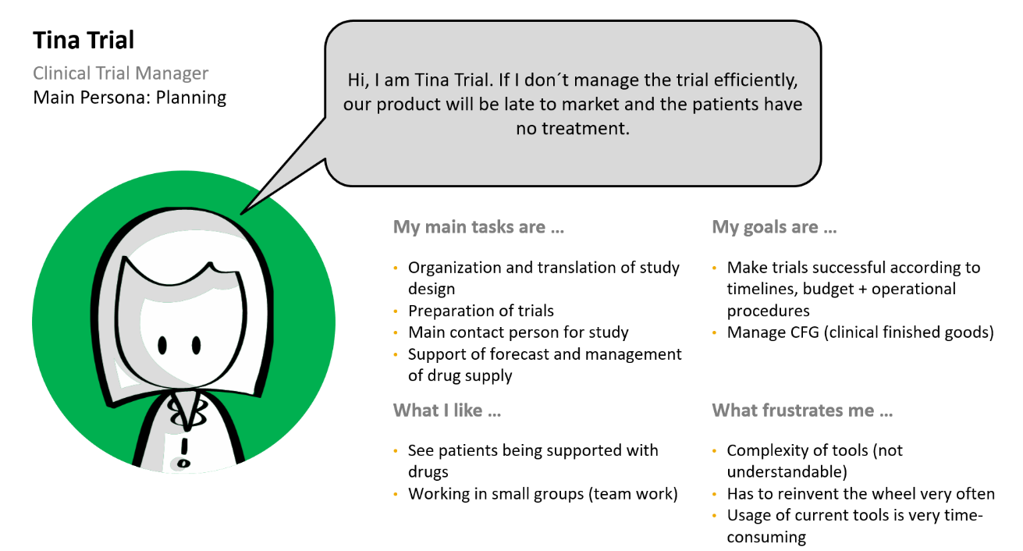

Figure 1: Persona - 3.2.1 Clinical Trial Manager

### Production Manager

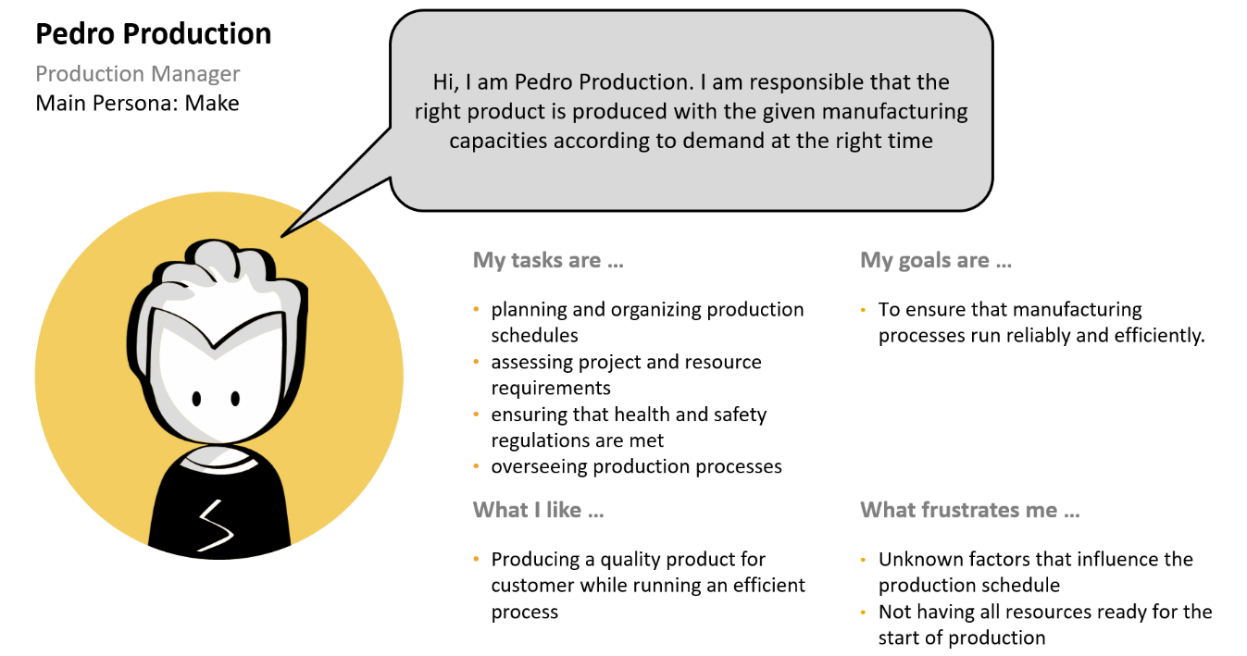

Figure 2: Persona - 3.2.2 Production Manager

### Delivery Manager (Corporate / Warehouse)

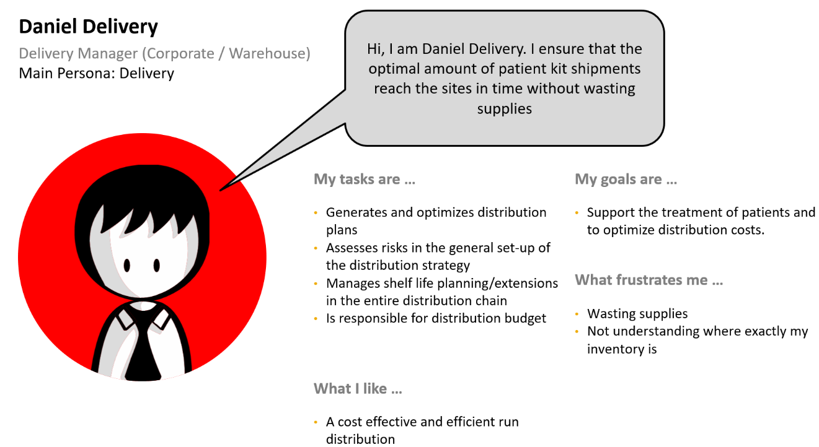

Figure 3: Persona - 3.2.3 Delivery Manager (Corporate / Warehouse)

### Supply Chain Planner

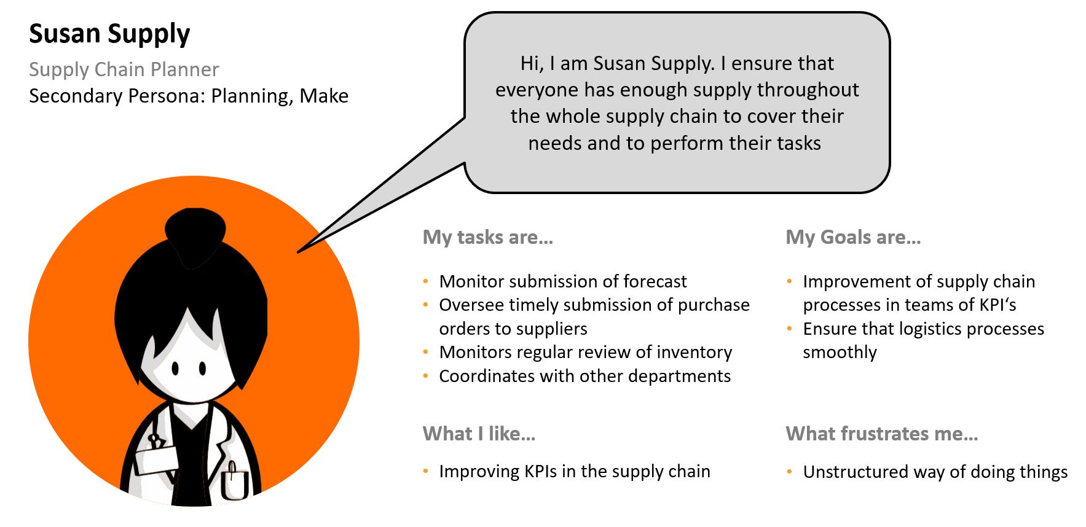

Figure 4: Persona - 3.2.4 Supply Chain Planner

### Clinician

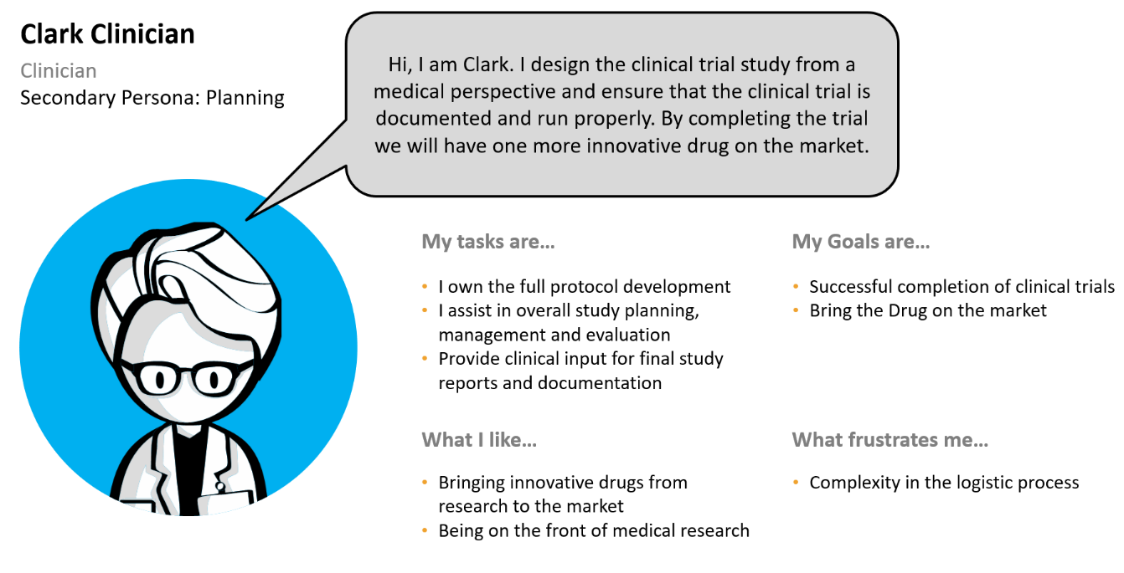

Figure 5: Persona - 3.2.5 Clinician

### Shopfloor Manager

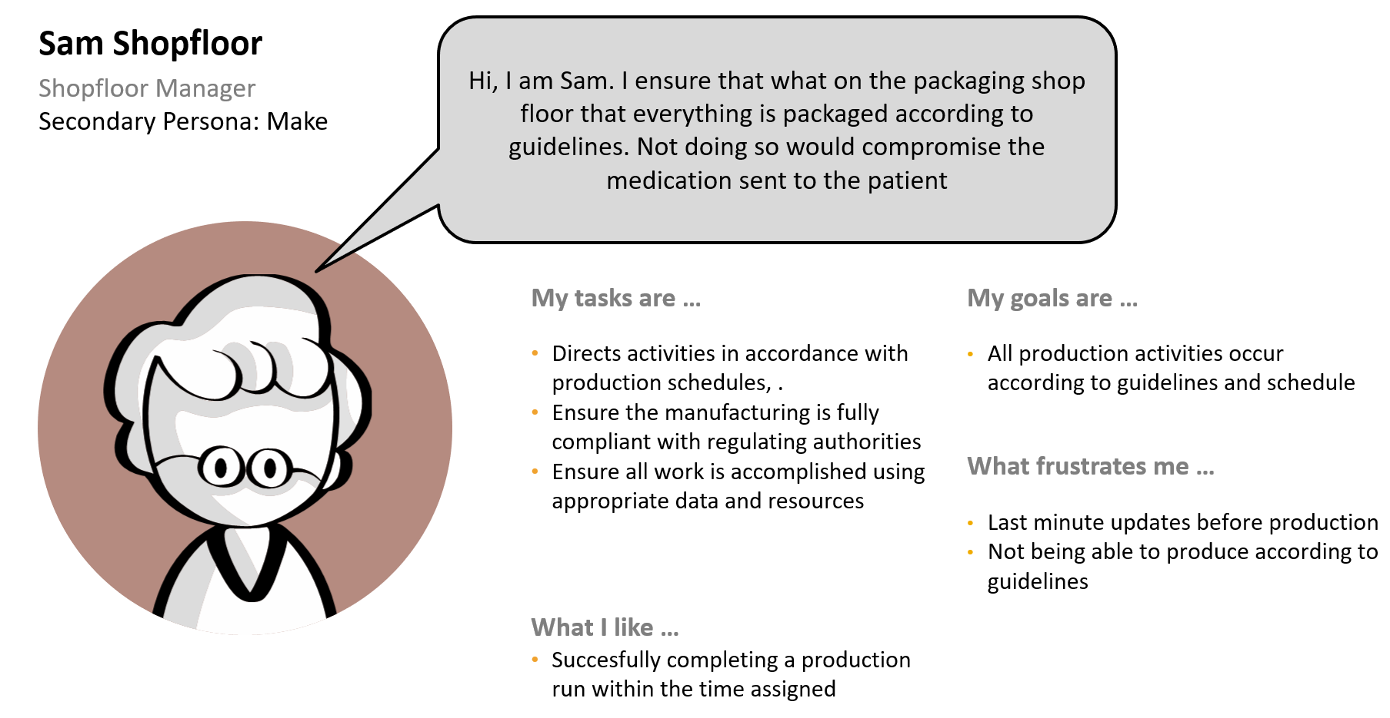

Figure 6: Persona - 3.2.6 Shopfloor Manager

### Warehouse / Depot Clerk

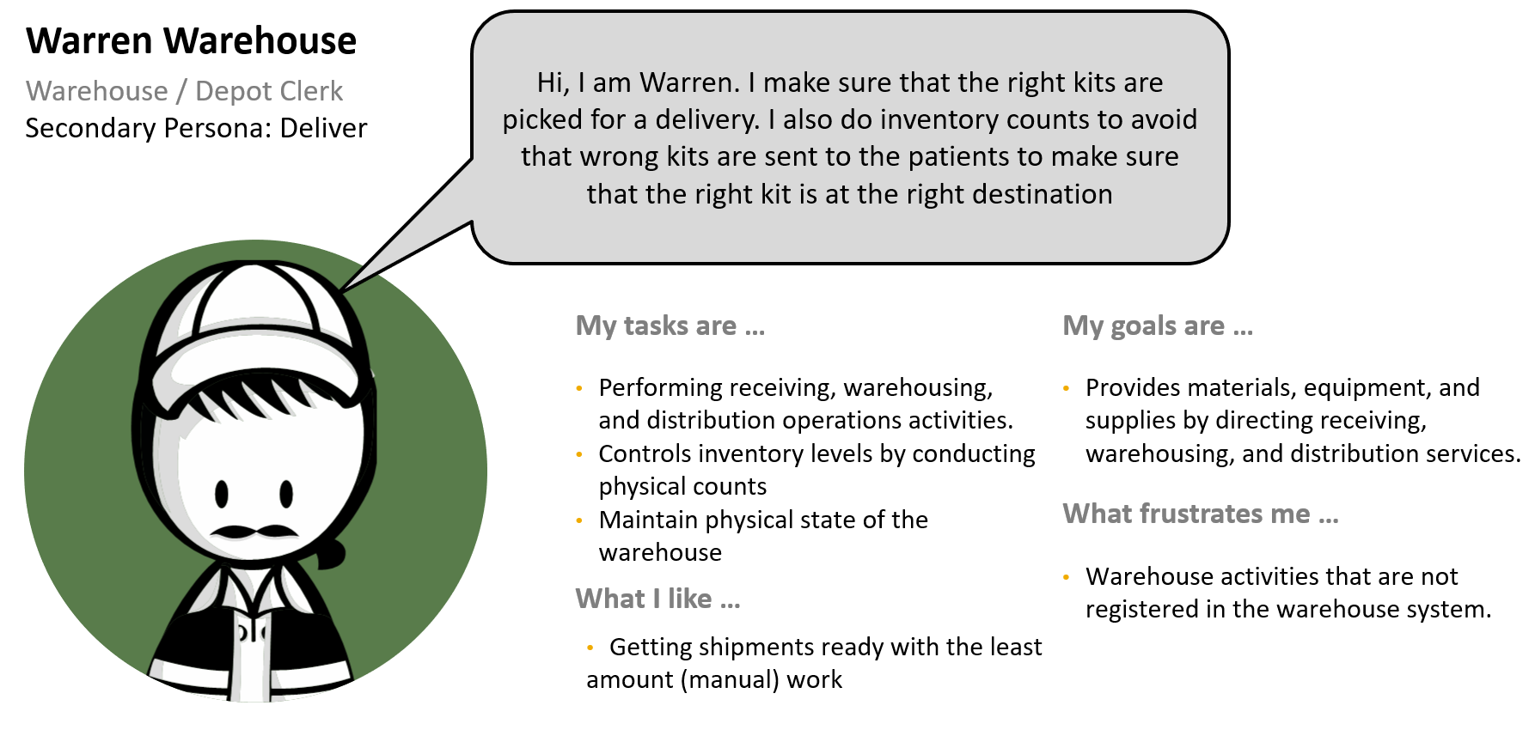

Figure 7: Persona - 3.2.7 Warehouse / Depot Clerk

### Quality Manager

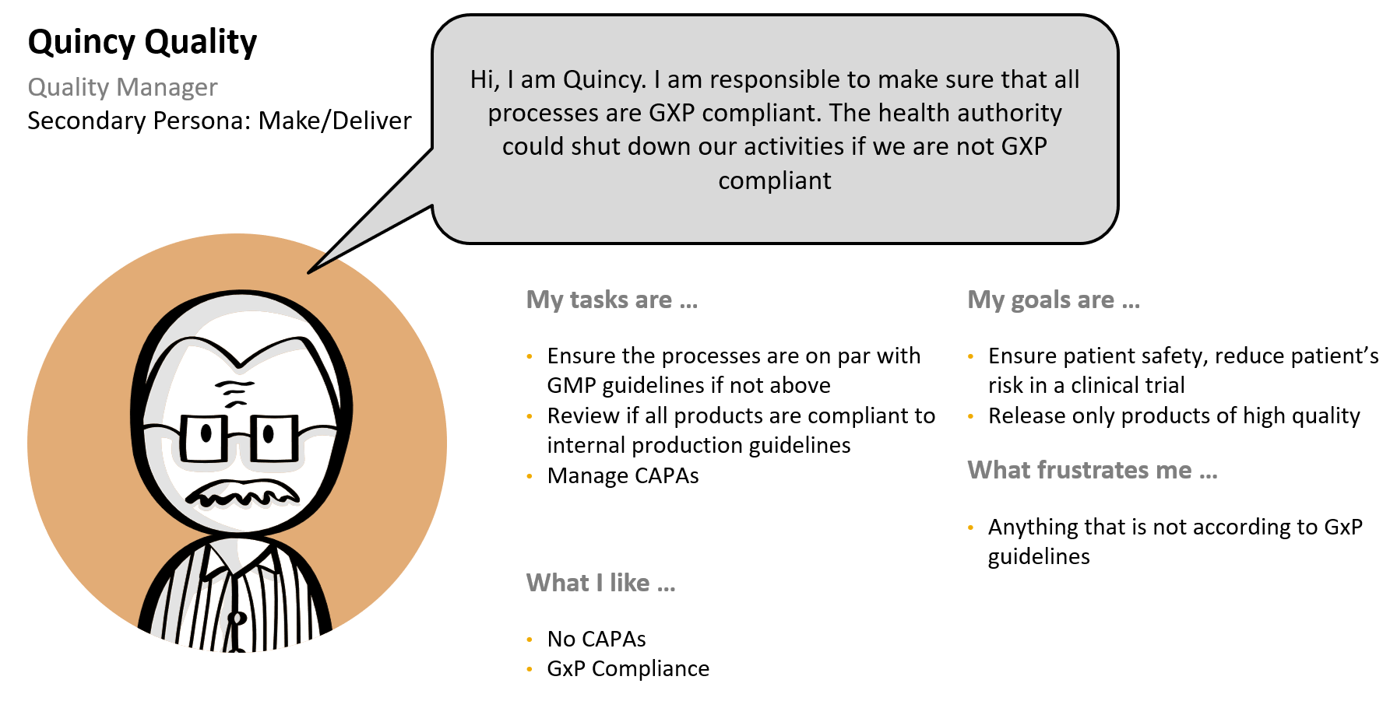

Figure 8: Persona - 3.2.8 Quality Manager

### Regulatory Affairs Manager

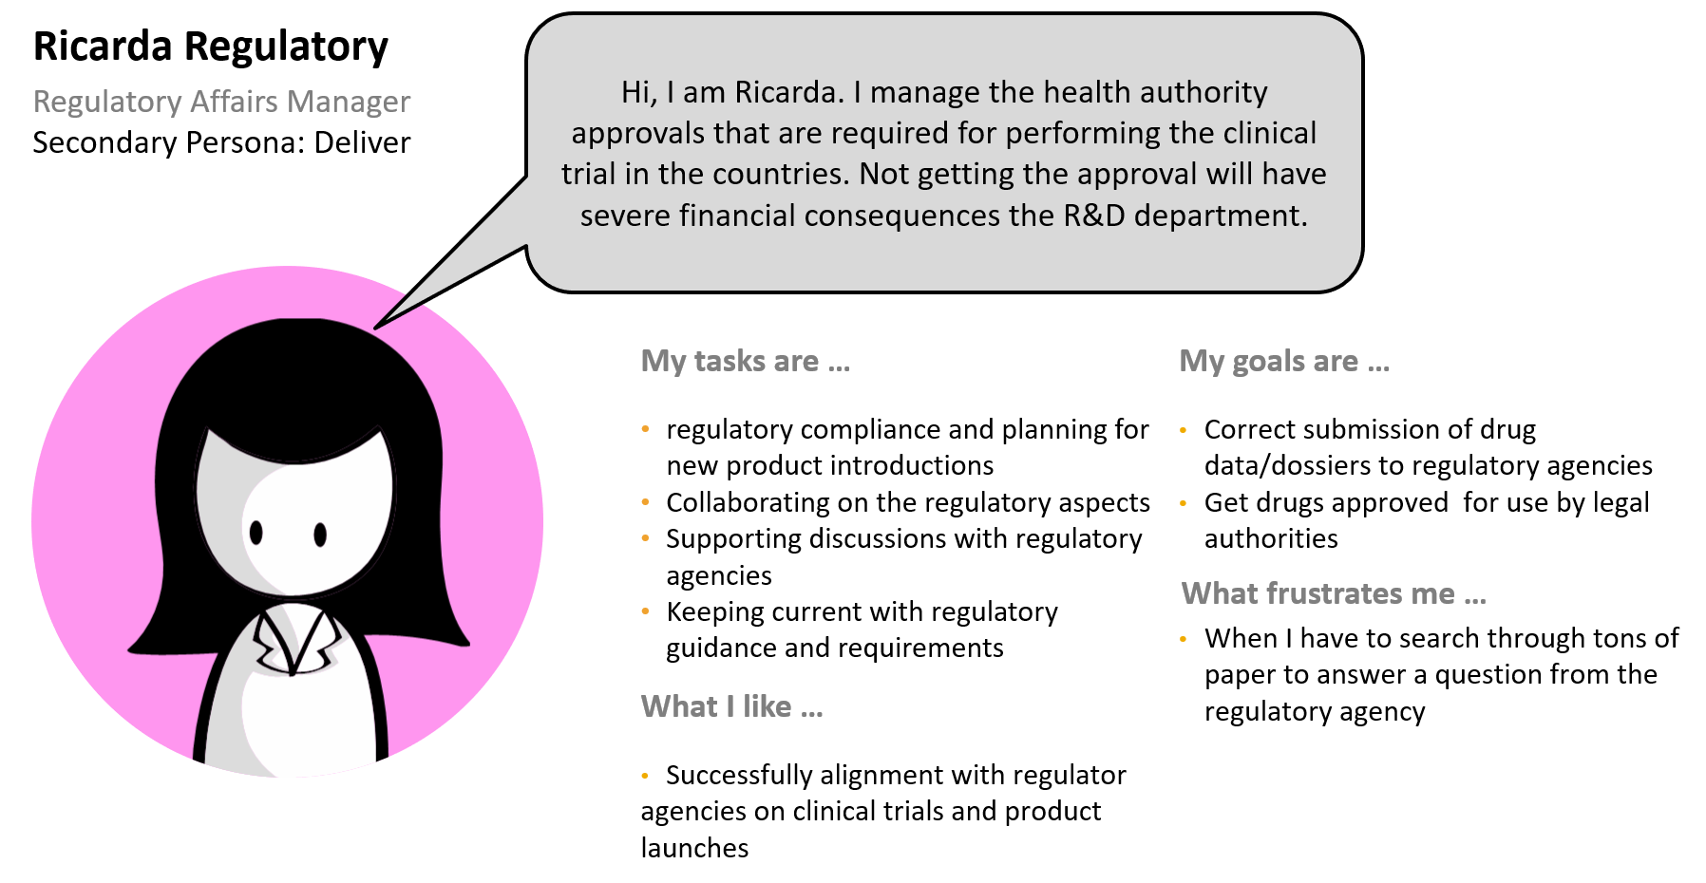

Figure 9: Business Process Overview

### Label Translator

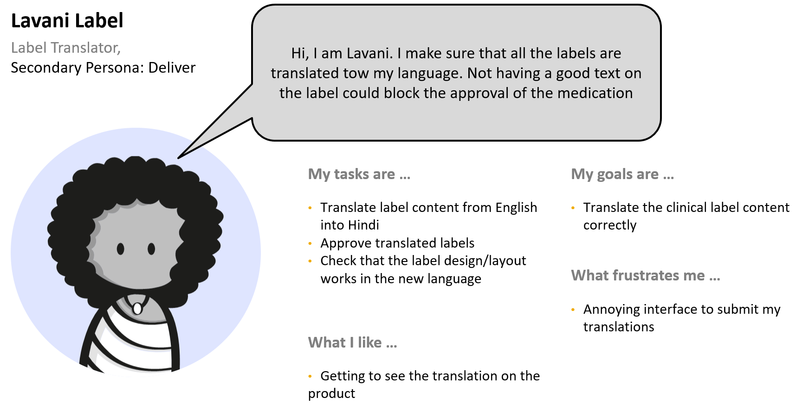

Figure 10: Persona - 3.2.10 Label Translator

### IT

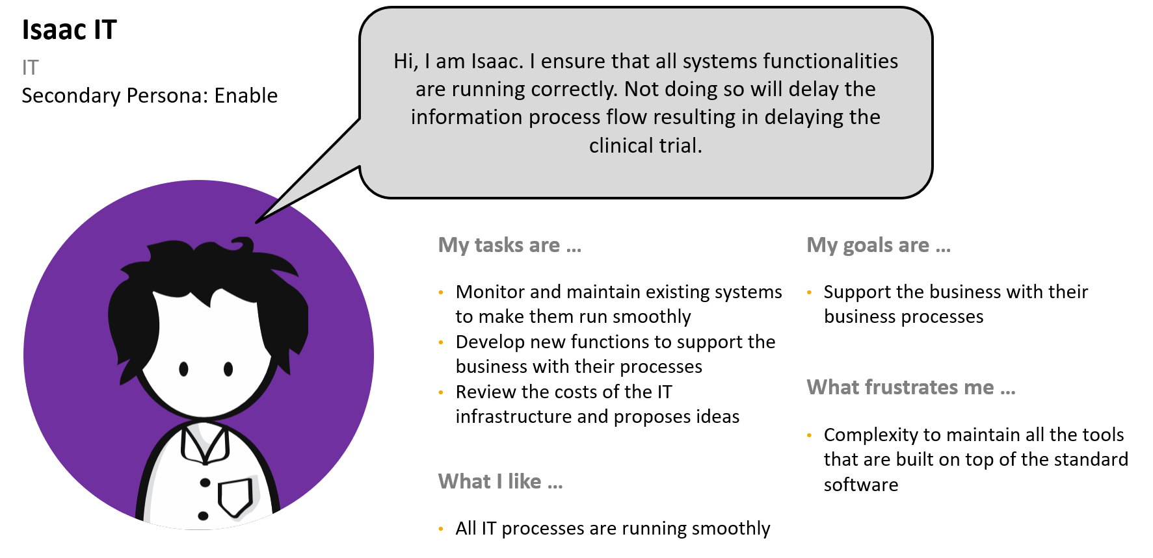

Figure 11: Persona - IT

- MANDATORY section

// FILLED IN BY: Business Innovation Consultant and/or IBSO //

- Describe different users’ responsibilities, and problems. Describe how they currently deal with the challenges, what they think will solve their problems, and what their information needs are.

- Use this section to capture the voice of the user at a very high level, not user requirements.

- You can use personas here. These are archetypes that help identify your users’ profiles, needs, wishes, and expectations in order to design the optimal experience for them.

For example:

Sales Analyst: Sandy is a sales analyst who will use <app> to create dashboards and analyze trends. Her information must be analyzed reliably, and she needs to feel confident of the conclusions she draws. She needs expertise in the SAP reporting and analysis tools and wants to learn about new functionality or best practices that can give her an edge.

- You can structure your personas by listing list individual motivations, concerns, and frustrations.

## Project Stakeholders

- OPTIONAL section - delete if not relevant

// FILLED IN BY: Business Innovation Consultant and/or IBSO //

- Describe the stakeholders, degree of involvement, their expectations, and what information they expect to receive.

- Stakeholders are parties that are involved or impacted by the development project.

| Stakeholder Role | Involvement | Expectations | Information Needs |
| --- | --- | --- | --- |
|  |  |  |  |
|  |  |  |  |
|  |  |  |  |
|  |  |  |  |

## Business Processes

The solution contains the five major process steps **planning**, **make**, **deliver**, **the actual trial** and **enable**. The following diagram illustrates the dedicated phases including the related sub-tasks for each step.

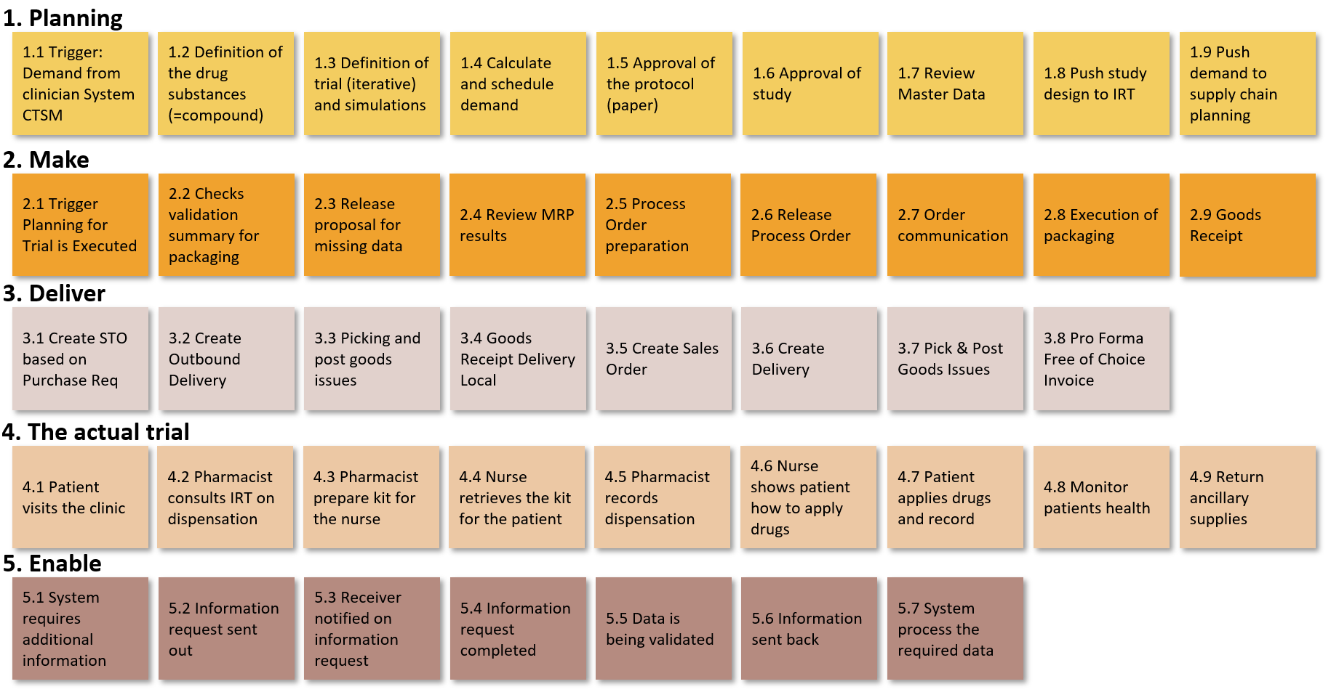

Figure 15: Business Process Overview

The following chapters provide an overview of each process, mapped with the involved personas.

### Planning

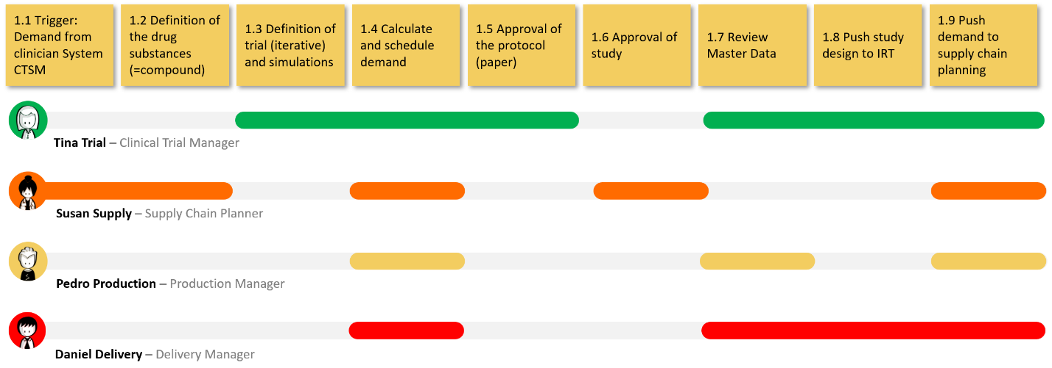

Figure 16: Business Process - Planning

### Make

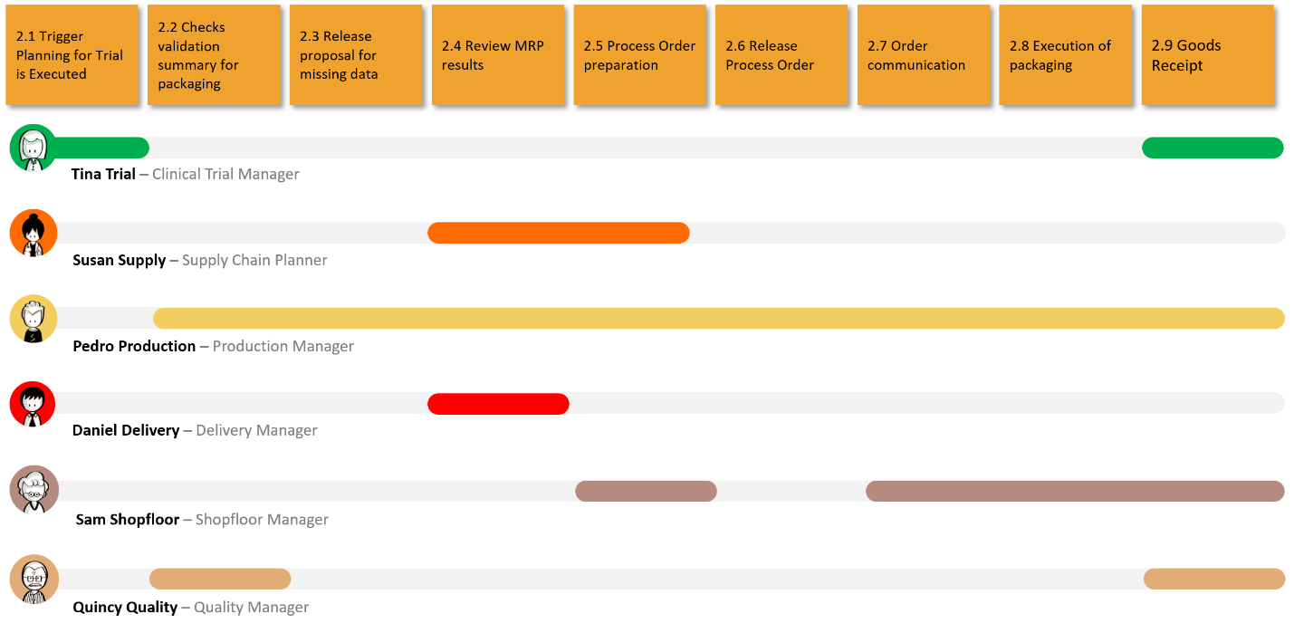

Figure 17: Business Process - Make

### Deliver

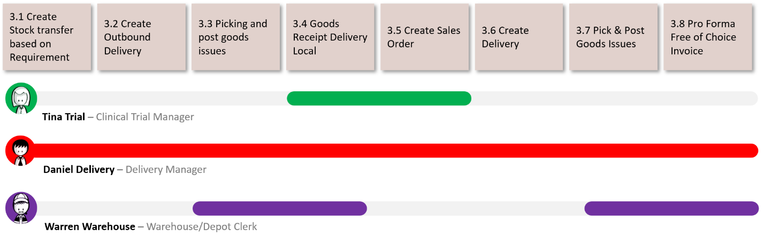

Figure 18: Business Process - Deliver

### The actual trial (Out of scope)

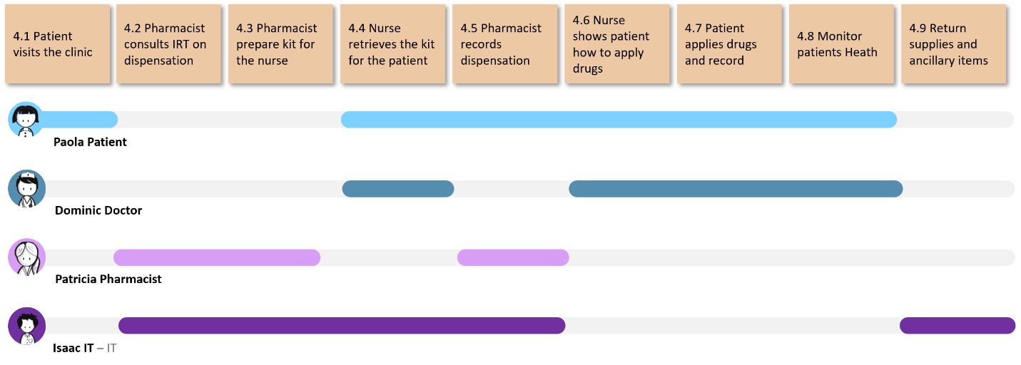

Figure 19: Business Process – The actual trial

### Enable

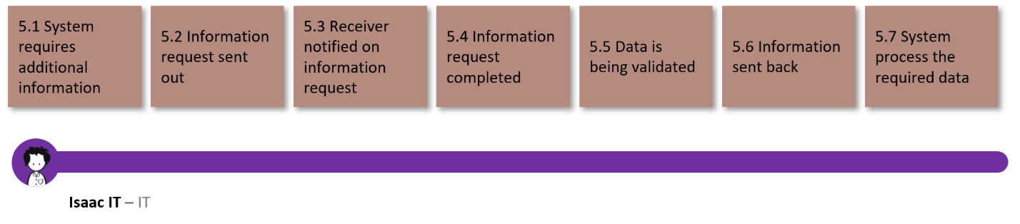

Figure 20: Business Process - Enable

- OPTIONAL section - delete if not relevant

// FILLED IN BY: Business Innovation Consultant and/or IBSO //

- Describe the relevant business processes currently in place. Use diagrams to illustrate. Keep this at a reasonably high level; it should not be overly technical and detailed.

- Use this to describe the customer's current situation, if necessary. Do not use this section to describe the scope.

- As much as reasonable, use business language and avoid SAP jargon.

## Rules and Regulations

- OPTIONAL section - delete if not relevant

// FILLED IN BY: Business Innovation Consultant and/or IBSO //

- Are there non-negotiable policies, rules, or regulations that define or constrain aspects of the business? If so, state them here.

- Examples: Corporate policies, government laws and regulations, industry standards;

- Keep these separate from business requirements.

- Recommendation: List in a table format with IDs.

- If no such rules exist, delete this section.

| Rule or Regulation | Description |
| --- | --- |
| GxP? |  |
|  |  |
|  |  |

# Vision and Business Value

- Do not enter text directly here under the main section heading; use the subsections.

## Vision Statement

For Pharma companies, who run clinical trials to get their drugs approved for their target markets, the CTSM solution offers a compelling way to plan clinical trials and ensure there is the right amount of medication available at the sites (hospitals) to actually execute the trial without interruption. Unlike other solutions, the new CTSM solution offers web based SAP Fiori screens, a part that runs on cloud (study master and planning) and an integration into S4 systems, which run the make, deliver and enable parts.

- MANDATORY section

// FILLED IN BY: Business Innovation Consultant and/or IBSO //

- State what the solution can help the customer attain.

- This should be short and compelling. The vision statement provides the context for making decisions on what is in or out of scope during the entire project cycle.

- Suggested pattern:

For <target customer>, who <statement of customer need or opportunity>, the <product name> is a <product category> that <key benefit, reason to buy>. Unlike <main competitive alternative>, our product <statement of primary differentiation>.

Example:

For ACME Inc., one of the largest producers of important things, who needs a new thing management tool, the New SAP Solution is a web-based SAP Fiori application that allows ACME to manage the thing process uniformly across their entire organization. Unlike the current manual and cumbersome process, the New SAP Solution provides a uniform approach to manage the thing process and monitor the progress through built-in analytics.

## Value Proposition

- MANDATORY section

// FILLED IN BY: Business Innovation Consultant and/or IBSO //

- Clearly state the business value that the software will provide for the customer.

- Describe the business problems, business objectives, and value proposition. Use business language and avoid SAP jargon.

- These are NOT software requirements. The proposed solution will have software features in support of the business objectives.

- Business objectives often address certain problems that a company has and express the desire to save costs, decrease time spent on processes, or increase revenue.

Example:

ACME has challenges with managing a high volume of contractor timesheets, with high processing costs and frequent incorrect payments to contractors. ACME wants to reduce processing time by 50% and reduce the occurrence of incorrect payments to less than 1 in 10,000.

- NOTE: these are the customer’s objectives, and IBSO will normally not commit to achieve any stated improvement percentages or other specific key figures.

- Recommendation: Use enumerated lists of objectives. Use modelling techniques to visualize.

## Time-to-Value Aspects

To decrease the time to value, the solution is delivered in several waves. The first wave includes a first version of the study master and planning in the cloud but no integration into S4 systems. The second wave contains more developments on the planning part and the S4 parts.

- OPTIONAL section - delete if not relevant

// FILLED IN BY: Business Innovation Consultant and/or IBSO //

- Are there time-to-value aspects relevant for the customer? This could be:

- What would be the benefit to go live with a Minimum Viable Solution and add other features later?

- What would be additional value of a faster time to value? Would some value not be realized if a certain time to market is not achieved?

- Could Continuous Delivery increase the realized value for the customer?

## Business Metrics

- OPTIONAL section - delete if not relevant

// FILLED IN BY: Business Innovation Consultant and/or IBSO //

- A business metric describes a measurable value that the customer uses to monitor their business success.

- For example, business metrics might measure the following:

- Increase in online sales

- Reduction in number of calls to call center

- Reaching new target groups

For more background information, see the IBSO Wiki: [Customer's Business Metrics](https://wiki.wdf.sap.corp/wiki/x/Fdj3f)

| Business Metric | How Measured |
| --- | --- |
| Time to approval of new treatments | Shorter time to approval |
| Cost of clinical trial supply management | Reduced cost |
|  |  |

## Business Viability

- OPTIONAL section - delete if not relevant

// FILLED IN BY: Business Innovation Consultant //

- Business viability defines the commercial case for the opportunity and how it will generate new revenue and business impact

- Describe the commercial model

- Describe details of the business case, such as the cost and benefit structure, and how the opportunity will create value over time

# Solution Scope

Do not enter text directly here under the main section heading; use the subsections.

## Scope Overview

- MANDATORY section

- // FILLED IN BY: IBSO //

 Note

This section provides a high-level overview of what is to be developed.

## Product Backlog

- MANDATORY section

- // FILLED IN BY: IBSO //

- Add the title of the product backlog here.

- Formulate the document title as follows, for example: Product Backlog for New Software

- Deliver the product backlog as a separate document.

- Optionally, you can add a list of the major epics.

The software-related requirements that make up the actual scope are described in the product backlog.

 Note

If you are using the agile development approach, the content and prioritization of the product backlog may change.

Product backlog: <document title>

## Nonfunctional Requirements

Describe the most important (for example, the top 3) qualities that define non-functional requirements for the solution in sub-chapters. Typical candidates: resilience, performance, availability, security.

- Sections are provided below for the most common types of nonfunctional requirements. If necessary, you can add others as subsections here.

- Do not enter text directly here under the main heading; use the subsections.

This list should include all nonfunctional requirements that are relevant for the architecture.

Examples:

- Performance requirements that might require parallelization

- Availability requirements that may restrict architectural options

### Cloud Qualities

The cloud part will be built on SAP Cloud Platform Cloud Foundry environment, thus it will employ a cloud native architecture that brings certain qualities with it. The application will be split in several microservices which will make use of resiliency patterns to achieve high availability of the services. Additionally, the stateless design of cloud native architectures provides the possibility to horizontally scale the application, if required, to achieve better performance during peak times. Monitoring will as well be an important part, to be able to quickly identify and solve any problems. Just as monitoring, logging will be a core part to identify and resolve problems quickly.

### Design and Implementation Constraints

- OPTIONAL section - delete if not relevant

- // FILLED IN BY: IBSO //

- State all design and implementation constraints imposed by the customer or internally.

- Use an enumerated list.

### Additional Metrics

- OPTIONAL section - delete if not relevant

- // FILLED IN BY: IBSO //

Use the included subsections to describe any other metrics (in addition to any business metrics defined as part of the business background) that are relevant for the solution. If a type of metric is not relevant, remove it here.

For more background information, see the IBSO Wiki: [Metrics Overview](https://wiki.wdf.sap.corp/wiki/x/mNf3f)

Pricing Metrics

- OPTIONAL section - delete if not relevant

- // FILLED IN BY: IBSO //

These metrics are relevant for the pricing of the solution.

For example, the services might be priced by memory or CPU consumption. You could also count the number of sales orders created if that’s relevant for pricing. The system availability also has an impact on the pricing.

For more background information, see the IBSO Wiki: [Pricing Metrics](https://wiki.wdf.sap.corp/wiki/x/onoLfQ)

Usage Metrics

- OPTIONAL section - delete if not relevant

- // FILLED IN BY: IBSO //

These are metrics that allow you to measure the usage of a solution.

For example, this might be the usage of a particular feature, business usage measuring the number of sales orders created, or the number of airports using a refueling solution. These metrics can be used for renewal discussions or to ensure that “business as usual” is possible in operations. Unlike the customer’s business metrics, usage metrics are monitored by SAP - with the consent of the customer.

For more background information, see the IBSO Wiki: [Usage Metrics](https://wiki.wdf.sap.corp/wiki/x/tiZvfQ)

Fitness Functions

- OPTIONAL section - delete if not relevant

- // FILLED IN BY: IBSO //

These are metrics that you can use to protect important architectural characteristics of your solution. These metrics can be defined at the following levels:

- Atomic level, for example a unit test to ensure the performance of a transaction.

- System level, for example, system availability.

They can be tested using manual or automated tests.

For more background information, see the IBSO Wiki: [Fitness Functions](https://wiki.wdf.sap.corp/wiki/x/3pSTd)

Operational Metrics

- OPTIONAL section - delete if not relevant

- // FILLED IN BY: IBSO //

These are all metrics that are relevant for supporting the operations of the software system. Typical operational tasks include the monitoring of system availability, health, and resilience or the monitoring of alerts and customer tickets. You may also have operational business metrics that enable operations to assess whether “business as usual” is possible.

For more background information, see the IBSO Wiki: [Operational Metrics](https://wiki.wdf.sap.corp/wiki/x/wnoLfQ)

Experience Metrics

- OPTIONAL section - delete if not relevant

- // FILLED IN BY: IBSO //

This is a new area of expertise for SAP and IBSO: metrics for customer, employee, brand, and product experience. For IBSO solutions, they can also be used (in future) to enable Experience Management.

### UI Technology and Design Patterns

All UIs should follow the SAP Fiori guidelines as closely as possible using SAP UI5. If that is not possible, for a map integration, for example, the design will be realized using a “Fiori like” approach to enable a seamless user experience.

- OPTIONAL section - delete if not relevant

- // FILLED IN BY: IBSO //

Examples:

- The UIs will be implemented using SAP UI5 in a Fiori-like design.

### Data Model

Study Master

* Header Data (also in case of multi-protocol studies)
* Label Groups
* Trial Master
* Trial Matrix
* Country Parameters
* Study Parameters
* Regulatory & Quality Status

- OPTIONAL section - delete if not relevant

- // FILLED IN BY: IBSO //

Examples:

- The data model will expand the SAP S/4HANA data model.

- The data model must be based on the following best practice data model used in the industry.

### Interface Requirements

Interfaces will be developed using either OData or REST standards. All interfaces that are exposed to the outside require authentication.

Interfaces for integration of third-party products (CTSM, IRT) have to be versioned to mitigate breaking changes.

- OPTIONAL section - delete if not relevant

- // FILLED IN BY: IBSO //

Examples:

- OData interfaces will be used.

- The following interfaces must enable asynchronous data flow:

- Interface A

- Interface B

## Data Protection and Privacy

- MANDATORY section

- // FILLED IN BY: IBSO //

- DP&P requirements are Corporate Requirements and therefore mandatory for all projects. For more information, see [DP&P Guidance for SAP IBSO](https://wiki.wdf.sap.corp/wiki/x/4rwWcQ).

- Ensure that the statements below regarding DP&P requirements are based on requirements and information provided by the customer.

- For each DP&P requirement, state explicitly whether the requirement must be implemented. Use the relevant texts in each subsection below. Adapt the texts with care while adhering to the guidelines: [DP&P: Communication, User Assistance, and Terminology](https://wiki.wdf.sap.corp/wiki/x/TTpOcQ)

- If the solution is DP&P-relevant, then you must document how DP&P is implemented. You can include DP&P related information in an administration guide or in a standalone Security Information document. For more information on when to use what, see the section on [User Assistance for IDPs and CAEs](https://wiki.wdf.sap.corp/wiki/x/PCXXXQ) in the IBSO wiki.

Information related to data protection and privacy is provided as part of the solution documentation.

User-specific data will be stored in the database and kept as long as possible for historical data usage. It will be deleted after the deadlines of the GDPR regulation take effect.

The statements below regarding data protection and privacy requirements.

User Consent

SAP applications shall capture explicit user consent before collecting any personal data (SEC-224).

User consent management for collecting personal data is not part of this development because it will be handled by the customer by organizational measures.

Use applicable texts below if your software captures explicit user consent before collecting any personal data ([SEC-224](https://wiki.wdf.sap.corp/wiki/display/PSSEC/SEC-224)).

If user consent IS NOT needed, use ONE of the following texts here:

-The software to be developed does not collect any personal data.

- User consent management for collecting personal data is not part of this development because it will be handled by the customer by organizational measures.

- User consent management for collecting personal data is not part of this development because it will be handled by the customer in a different development project.

If user consent IS needed, use the following text:

- A function that requests consent from the user before storing personal data will be implemented.

Read Access Logging

SAP software shall log read access to sensitive personal data (SEC-254).

Read access logging is not necessary because the software to be developed does not process sensitive personal data.

Use applicable texts below if your software logs read access to sensitive personal data ([SEC-254](https://wiki.wdf.sap.corp/wiki/display/PSSEC/SEC-254)).

If read access logging IS NOT needed, use ONE of the following texts here:

- The software to be developed does not process sensitive personal data.

- Read access logging of sensitive personal data is not part of this project because it will be handled by the customer in a different project.

- Read access logging of sensitive personal data is not part of this project because it is explicitly not desired by the customer.

If read access logging IS needed, use the following text:

- Read access logging functionality will be provided for the following sensitive personal data: <data1>, <data2>, <data3>.

Information Report

SAP software shall provide a retrieval function which can be used to inform the data subjects about the personal data stored about them (SEC-255).

If user data persistence is needed on the SAP Cloud Platform, this must be clarified during the project.

Use applicable texts below if your software provides a retrieval function that can be used to inform the data subjects about the personal data stored about them ([SEC-255](https://wiki.wdf.sap.corp/wiki/display/PSSEC/SEC-255)).

If an information retrieval function IS NOT needed, use ONE of the following texts here:

- The software to be developed does not store personal data.

- A retrieval function for informing persons about personal data stored about them is not part of this project because it is handled by the customer in a different project.

- A retrieval function for informing persons about personal data stored about them is explicitly not desired by the customer.

If an information retrieval function IS needed, use the following text:

- A function for informing persons about personal data stored about them will be implemented.

Deletion of Personal Data

SAP software shall delete personal data when all applicable retention periods have expired (SEC-256).

If user data persistence is needed on the SAP Cloud Platform, this must be developed during the project. Personal data will be deleted as quickly as possible, at the latest with the expiring retention period.

Use applicable texts below in case your software deletes personal data when all applicable retention periods have expired ([SEC-256](https://wiki.wdf.sap.corp/wiki/display/PSSEC/SEC-256)).

If deletion of personal data IS NOT needed, use ONE of the following texts:

- The software to be developed does not store personal data.

- A deletion function for deleting personal data after retention periods have expired is not part of this project because it is handled by the customer in a different project.

- A deletion function for deleting personal data after retention periods have expired is not part of this project because it is explicitly not desired by the customer.

If deletion of person data IS needed, use the following text:

- A function for deleting the following personal data will be implemented: <data4>, <data5>, <data6>.

Change Log

SAP software shall log changes to personal data (SEC-265).

Change logging is not necessary because the software to be developed does not perform changes to personal data.

Use applicable texts below in case your software logs changes to personal data ([SEC-265](https://wiki.wdf.sap.corp/wiki/display/PSSEC/SEC-265)).

If change logging IS NOT needed, use ONE of the following texts here:

- The software to be developed does not perform changes to personal data.

- A function for logging changes to personal data is not part of this project because it is handled by the customer in a different project.

- A function for logging changes to personal data is not part of this project because it is explicitly not desired by the customer.

If change logging IS needed, use the following text:

- A function for logging changes to the following personal data will be implemented: <data7>, <data8>, <data9>.

## Out of Scope

* All scope items not assigned to Wave 1 are out of scope
* Process validation with regards to GxP regulations
* SAP Cloud Platform and the required platform services are not part of the proposal and offer and must be licensed or subscribed to separately.
* Any configuration/development with SAP Cloud Platform Integration to 3rd party solutions.
* Migration of existing customer data must be managed individually by each customer.
* Any other software components except those mentioned in the architecture diagram
* Customer-specific themes for user interfaces
* Role-specific adaption or variants of defined key UIs

- OPTIONAL section - delete if not relevant

// to be filled by IBSO //

- List features and other items that are out of scope.

# High-Level Architecture

- MANDATORY section

// FILLED IN BY: IBSO //

- Describe how the planned software addresses the known requirements. This documents what the software will be able to do.

- Avoid including design aspects more than necessary here. Design is part of the realization phase.

- Do not enter text directly here under the main section heading; use the subsections.

## System Landscape and Architecture Overview

- MANDATORY section

- // FILLED IN BY: IBSO //

- Describe the main architectural building blocks and their main interactions.

- Document the system landscape and relevant software components.

- Visualize the IBSO deliverables in the system and software component context.

- Use conceptual level TAM diagrams (block diagrams, activity diagrams, state diagrams) and other modelling techniques.

- Keep this to a high level. Avoid unnecessary technical details. This is not a detailed design.

- FORMAT YOUR GRAPHICS CORRECTLY, see the IBSO wiki for details: [https://wiki.wdf.sap.corp/wiki//x/YbQxY](https://wiki.wdf.sap.corp/wiki/x/YbQxY)

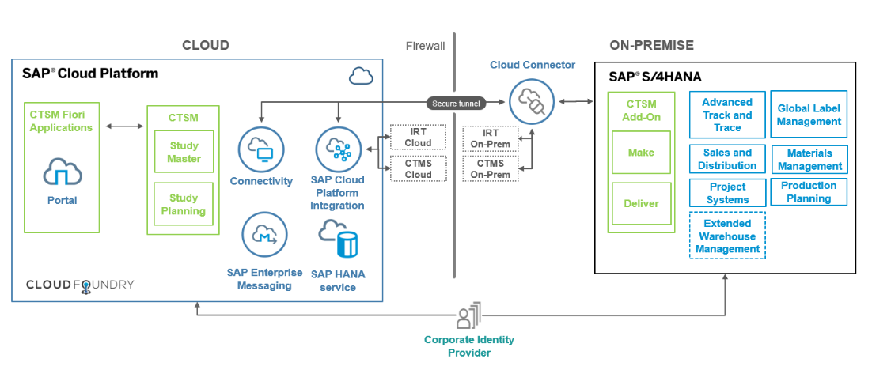

Figure 21: High-Level Architecture

The CTSM solution is split in two parts – one **SAP Cloud Platform** and one **S/4HANA on Premise component**. The cloud environment consists of the two pillars study master and study planning, whereas the processes for make, deliver will be part of an S/4 HANA add-on. This add-on will be seamlessly integrated with existing standard components like MM, PP, QM or SD.

The planning part on SCP has an own persistence layer (based on **SAP HANA**) and can be used as a stand-alone solution. However, the integration to S/4HANA (or any other third-party solutions like CTMS or IRT) can be achieved via **SAP Cloud Platform Integration** and the dedicated connectivity services in order to ensure the end-to-end process coverage.

Persistence for the Study Master and Planning components is provided by the **SAP HANA service**.

For asynchronous communication between the cloud microservices, the **SAP Enterprise Messaging** service is used.

All the user interfaces are based on SAPUI5 technology and follow the SAP Fiori guidelines. These applications will be exposed to the end-user via the **SAP Portal service**. The launchpad can be configured to contain all CTSM applications regardless of where the backend functionality is located (cloud or on-premise).

## Desirability

- Do not enter text directly here under the main section heading; use the subsections.

### UI Information Architecture

- OPTIONAL section - delete if not relevant

- // FILLED IN BY: IBSO //

- Focuses on organizing, structuring, and labeling content in an effective and sustainable way that makes sense to users. The goal is to help users find information and complete tasks efficiently.

- IA (Information Architecture) documents our understanding of the user’s mental model for completing tasks. Important aspects are:

- Organization: Categorizing and structuring information

- Labeling systems: How you represent information in the users’ terms

- Navigation systems: How users interact with the flow of information to complete tasks

- Search systems: How users look for information

- IA is usually created by a UX designer. Possible tools are Microsoft Excel or Adobe Illustrator, depending on the amount and level of effort.

- Note: This is often not yet available at the time of writing.

### UI Interaction Design

 Note

All mock-ups in this document serve only as illustrations. The actual UI implementation may deviate from the mock-ups.

### General aspects

• Role-based approach: Personas will access the CTSM system using a role-based launchpad. Customer-specific roles can be defined by the customer.

• Examples: Launchpads for study planner and supply chain manager.

• The SAP Fiori Launchpad allows for a theming per customer

#### Planning

Planning is used by two main personas. Tina Trial, who sets up the study and Susan Supply, who creates the demand planning. Both will have their own launchpad depicted in the following two mockups.



Figure 22: Demand Planning Launchpad



Figure 23: Trial Launchpad



Figure 24: Demand Workbook



Figure 25: Notification from CTMS

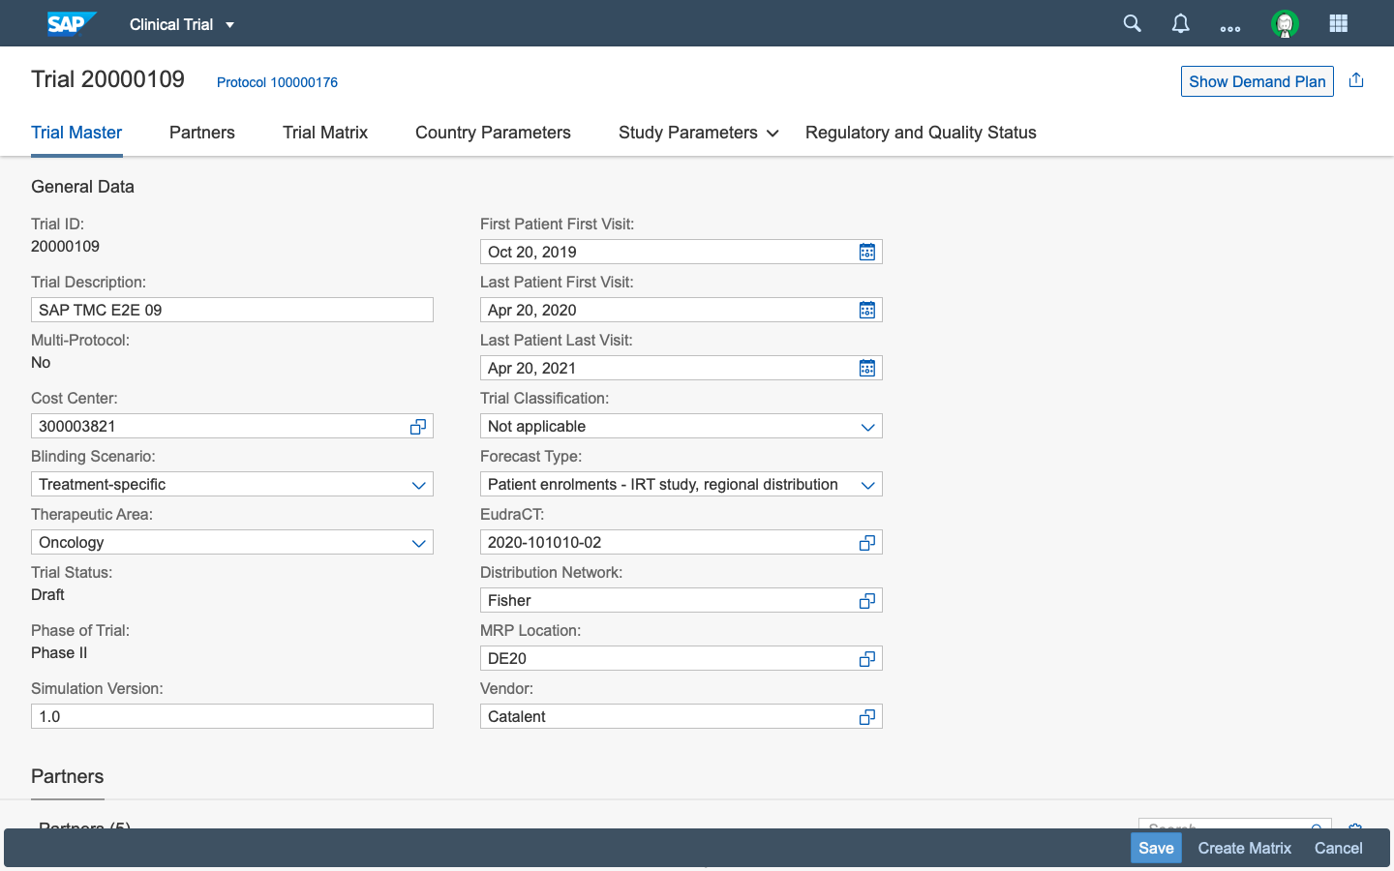

Figure 26: Study Creation (1)

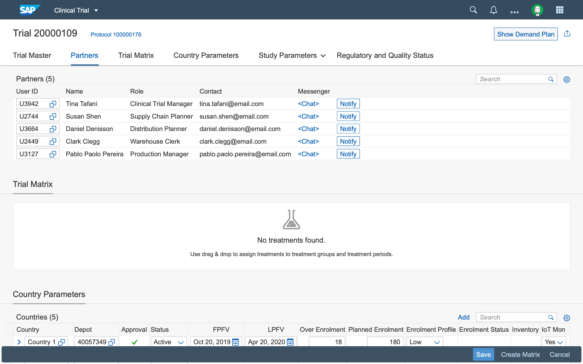

Figure 27: Study Creation (2)

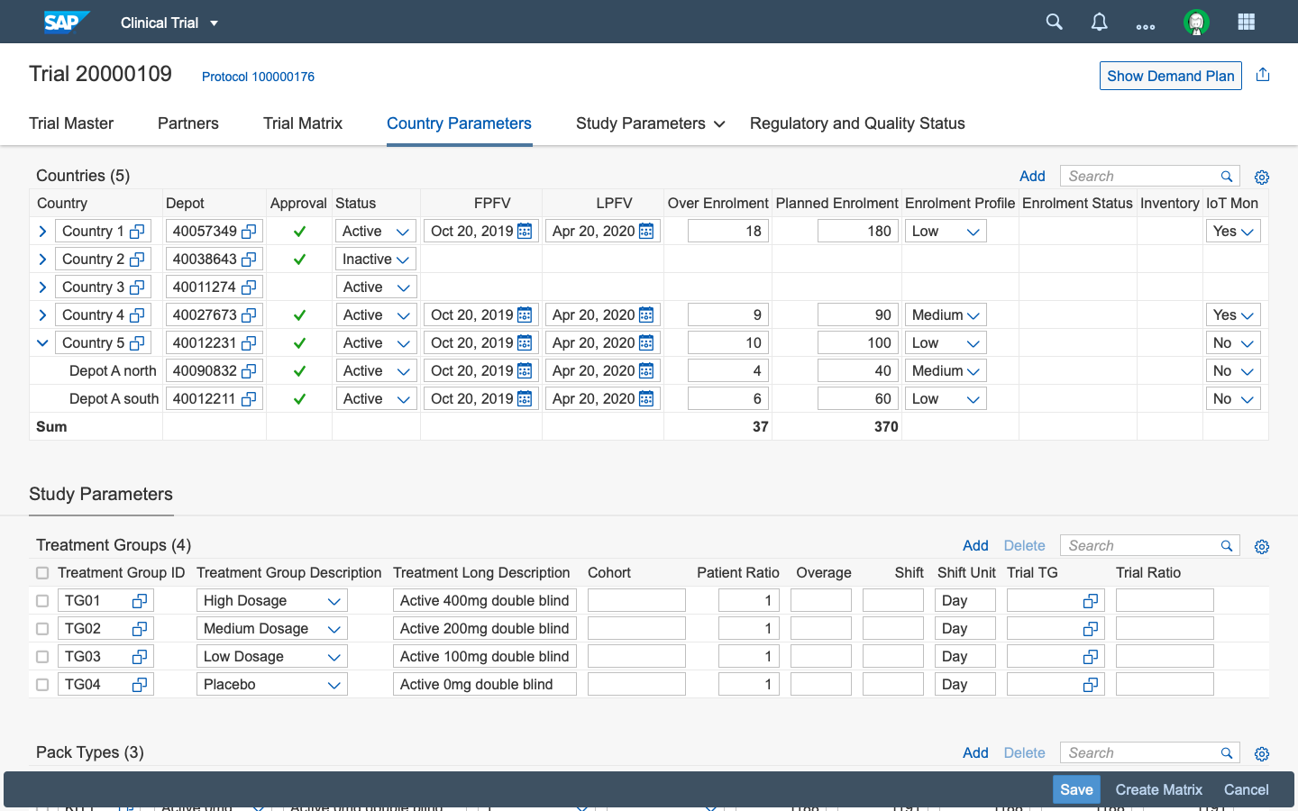

Figure 28: Study Creation (3)

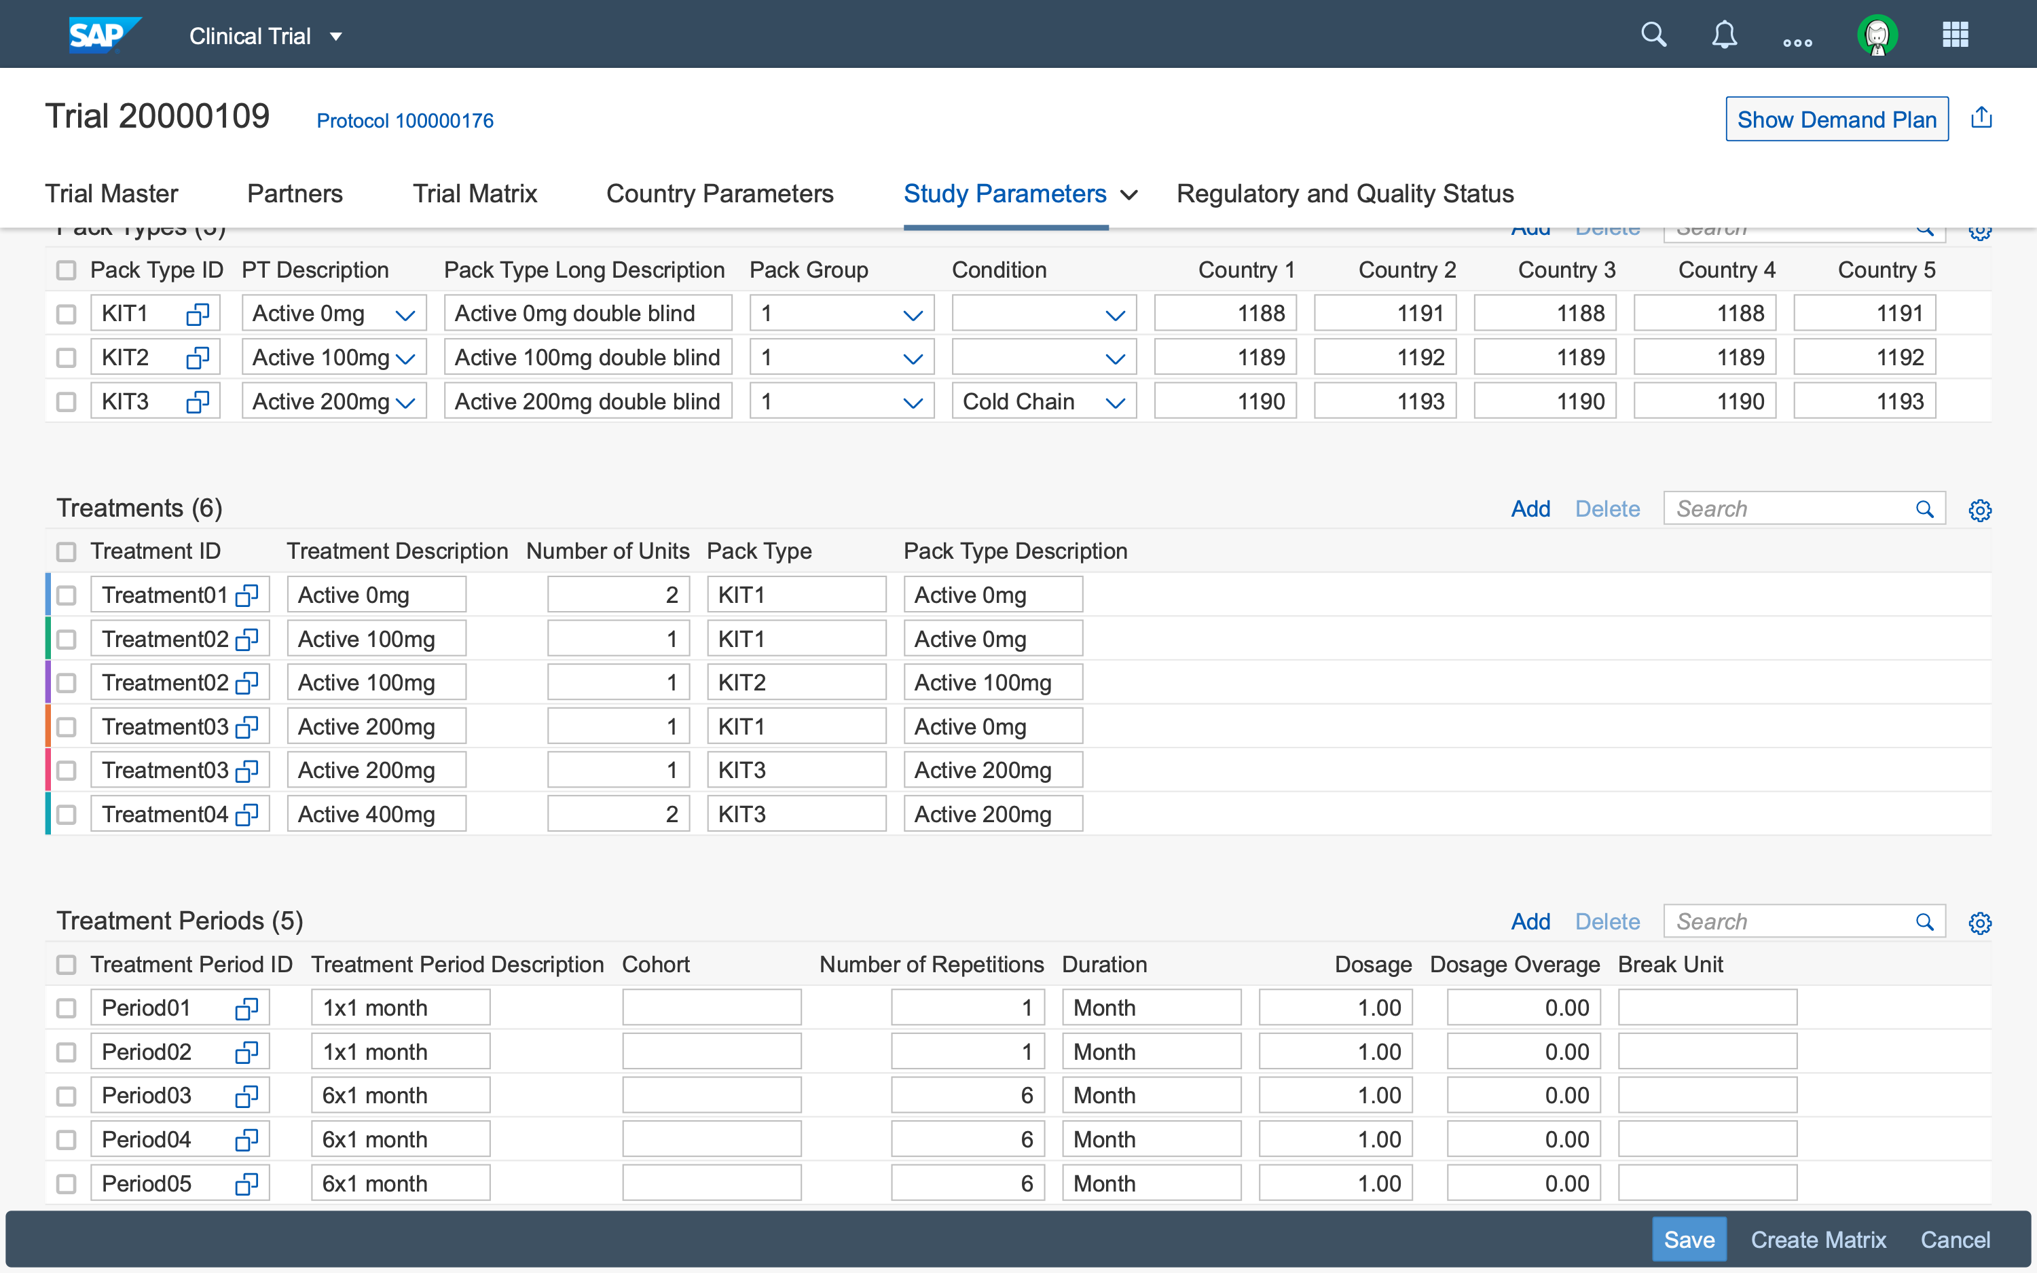

Figure 29: Study Creation (4)



Figure 30: Study Trial Matrix

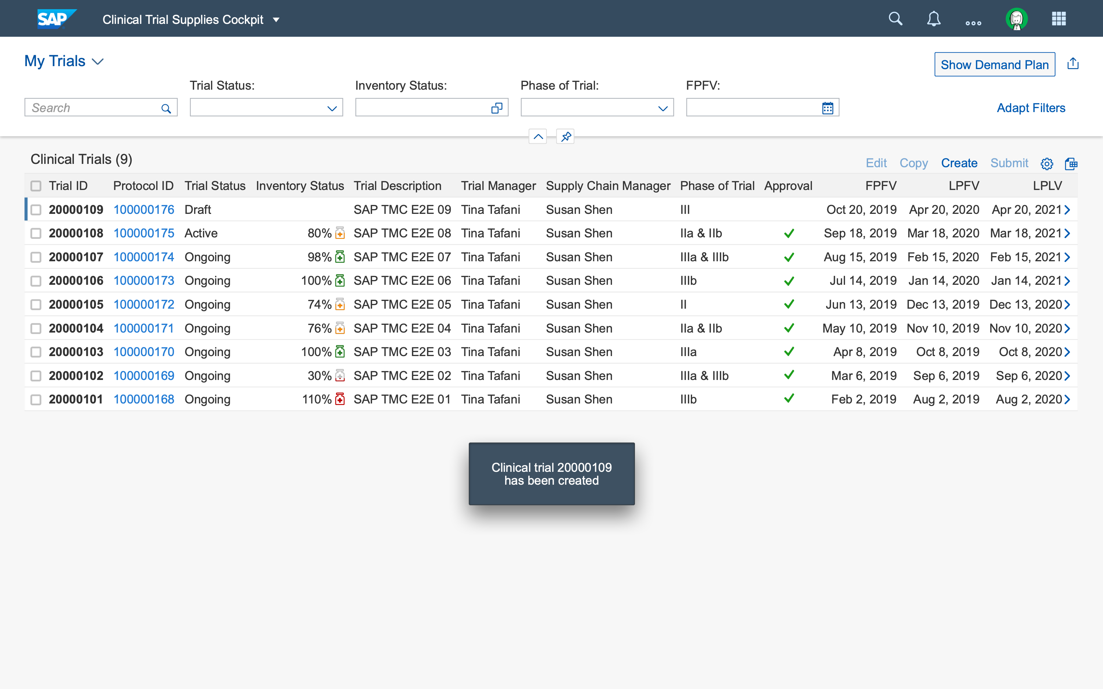

Figure 31: Trials Overview

- OPTIONAL section - delete if not relevant

- // FILLED IN BY: IBSO //

- Focuses on creating user interfaces with well thought-out behaviors and functions.

- Documents our understanding of how users and technology communicate with each other. This helps you anticipate how someone might interact with the system.

- Important aspects of interaction design are:

- Define how users interact with the interface

- Give users clues about behaviors and functions before actions are taken

- Anticipate and mitigate errors

- Consider system feedback and response time

- Think strategically about each element

- Possible tools: Adobe Illustrator (screen flows), Balsamiq (wireframes), InVision (clickable prototypes), Axure (wireframes, prototypes).

- Note: This is often not yet available at the time of writing.

## Prototype Information

- OPTIONAL section - delete if not relevant

// FILLED IN BY: Business Innovation Consultant and/or IBSO //

- If a prototype has been created, provide the following:

- Link to functional prototype including link to Git repository (if available)

- Git repository with source code and documentation

## Architecture Decisions

The decision for splitting the solution into a cloud and an on-premise part was made based on these aspects:

* Cloud Strategy: SAPs strategic platform is SAP Cloud Platform. Cloud Foundry provides a stable platform independent of the underlying IaaS provider. Study Master and Planning do not require a very close integration with S/4HANA.
* Customer Requirements: While large pharma companies are usually running S/4HANA on-premise, the Study Master and Planning components could also be used by customers with other ERP solutions (SAP ECC or SAP S/4HANA Public Cloud or third party). With the decision to decouple these components from S/4HANA, other ERP solutions can be connected in future releases.
* Third party applications: Many clinical applications (e.g. CTMS) are already available as cloud editions. Integration with these becomes easier if CTSM is also on cloud.
* Future proof: Cloud applications allow for future extensions such as IoT integration, integration with third-parties, …
* Availability of SAP Cloud Platform Integration: SAP Cloud Platform Integration allows integration of both on-premise and cloud solutions.
* Close integration with production, supply chain: The processes of Make, Deliver, Enable are mostly based on existing processes on S/4HANA. Implementing the necessary adjustments to those processes directly on S/4HANA reduces the technological risk and development efforts for CTSM.

- OPTIONAL section - delete if not relevant

- // FILLED IN BY: IBSO //

- Use this section to document any significant architectural decisions made

# Feasibility

- Do not enter text directly here under the main section heading; use the subsections.

## Prerequisites, Dependencies, and Assumptions

* Customers using this solution should determine the GxP requirements that apply to their computerized systems, based on the intended use and then follow internal procedures, governing qualification and validation processes to demonstrate that they have met those requirements.
* The Cloud solution cannot run in any arbitrary data center or hyperscaler. Initially, the CTSM could solution will only be available on Amazon Web Services Frankfurt.
* Customer is responsible for monitoring the business process, including message processing logs in CPI with the dedicated standard tools, along with documentation as a part of the baseline cloud platform.

- MANDATORY section

// FILLED IN BY: Business Innovation Consultant and/or IBSO //

- Use this section to document any prerequisites, dependencies, and assumptions

- These can concern both technical and architecture perspectives as well as project-related aspects.

## Risk Management

- OPTIONAL section

// FILLED IN BY: Business Innovation Consultant //

- Describe insights from a risk analysis (for example, regulatory, legal, compliance, security) and detail a risk mitigation plan to address them

# Open Points

- OPTIONAL section - delete if not relevant

// FILLED IN BY: Business Innovation Consultant and/or IBSO //

- State any open points.

- Aim to keep this to a minimum.

DO NOT DELETE THIS SECTION BREAK